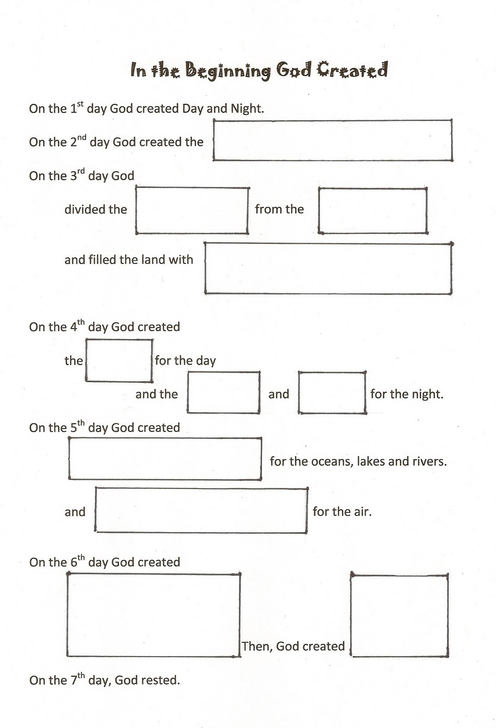
Directions:
You can either write the missing words of the story of creation or draw a picture for each missing part.

